**ASSIGNMENT 6**

**REGULAR EXPRESSIONS**

Submitted by: AKSHAY JAIN

Registration Number: 17BCS002

**Note:** Reference Tables at the end

**Exercise 1**

* Query:

SELECT * FROM Customer, Policy WHERE last_name REGEXP "C"

* View:

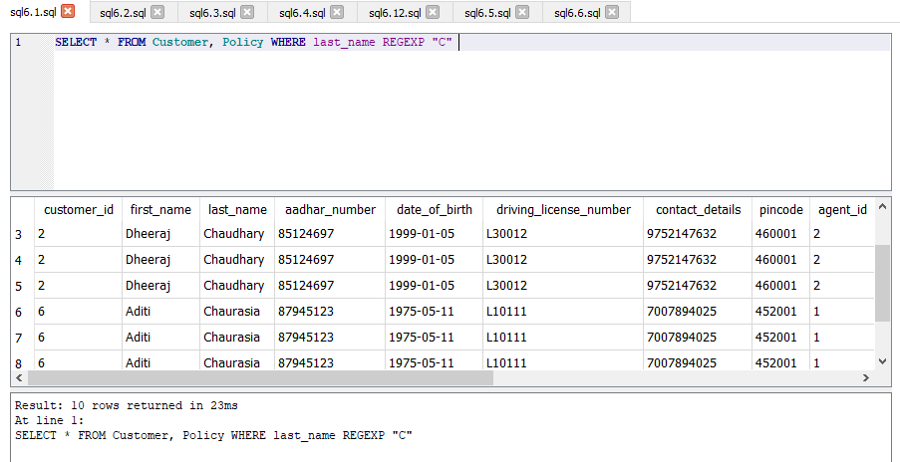

**Exercise 2**

* Query:

SELECT * FROM Insurance WHERE insurance_type REGEXP "^[ABCD]"

* View:

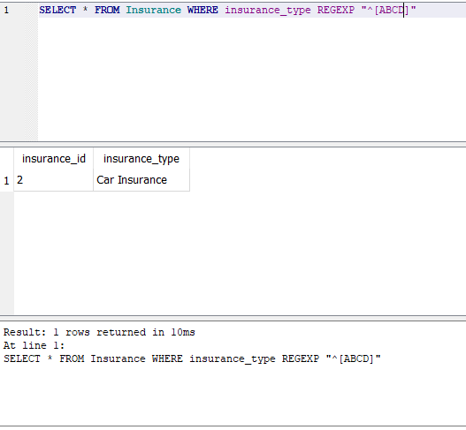

**Exercise 3**

* Query:

SELECT * FROM Insurance WHERE insurance_type REGEXP "^[^ABCD]"

* View:

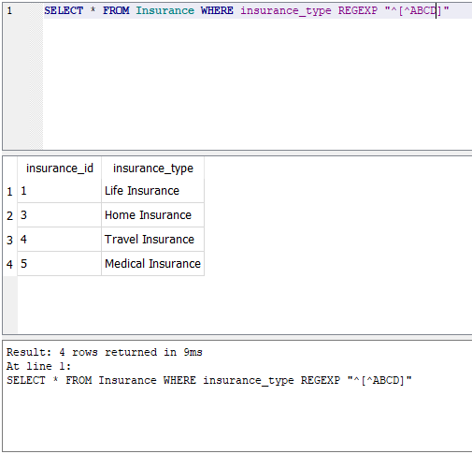

**Exercise 4**

* Query:

SELECT * FROM Customer WHERE last_name REGEXP "Ch*"

* View:

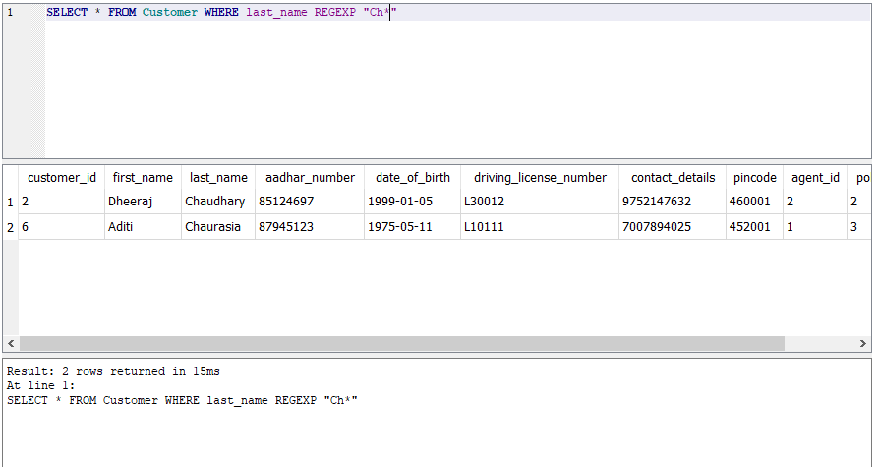

**Exercise 5**

* Query:

SELECT * FROM Agent WHERE pincode REGEXP "4+"

* View:

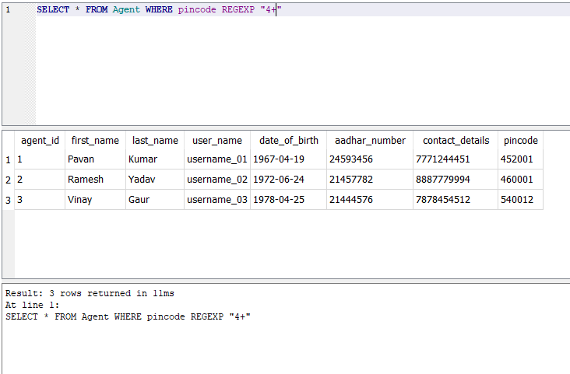

**Exercise 6**

* Query:

SELECT * FROM Policy WHERE term_cost REGEXP "8?"

* View:

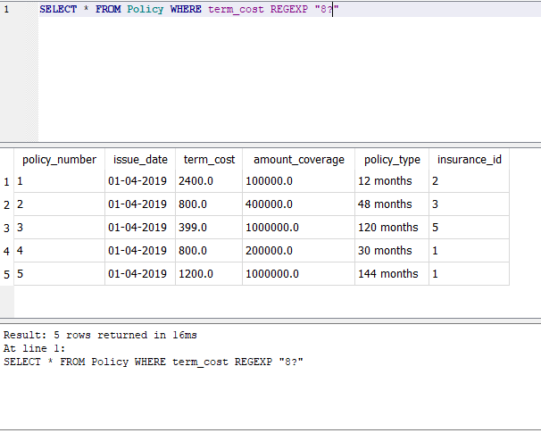

**Exercise 7**

* Query:

SELECT * FROM Policy WHERE term_cost REGEXP "1."

* View:

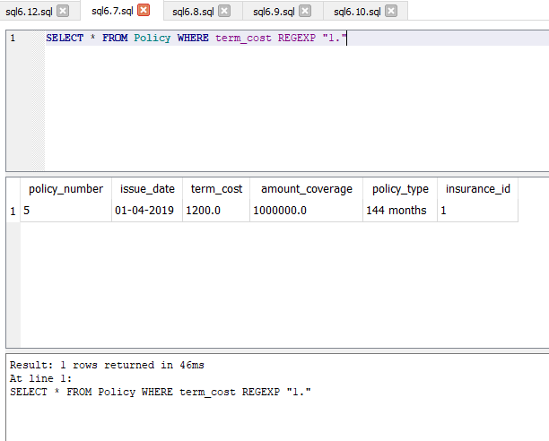

**Exercise 8**

* Query:

SELECT * FROM Agent WHERE first_name REGEXP "[A-Z]"

* View:

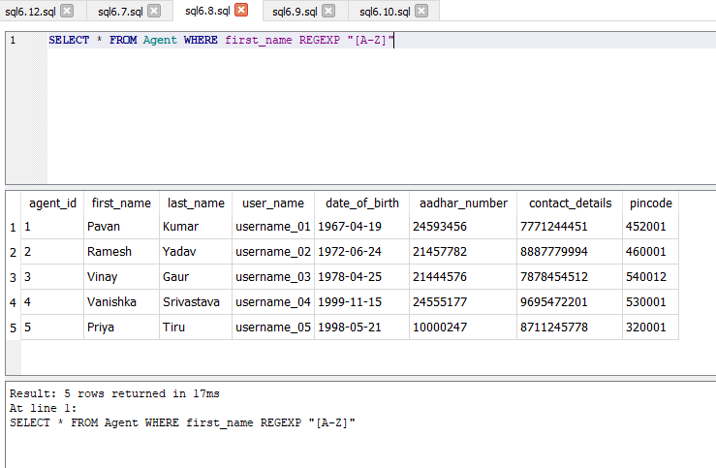

**Exercise 9**

* Query:

SELECT * FROM Customer WHERE driving_license_number REGEXP "[0-9]"

* View:

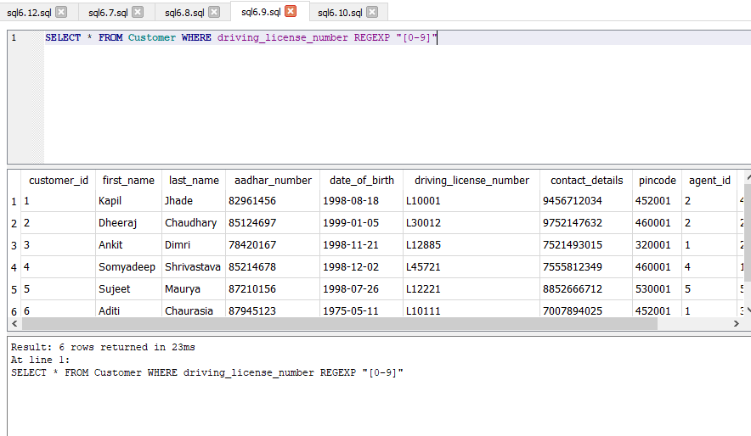

**Exercise 10**

* Query:

SELECT * FROM Address WHERE city REGEXP "^[AB]|^[IJ]"

* View:

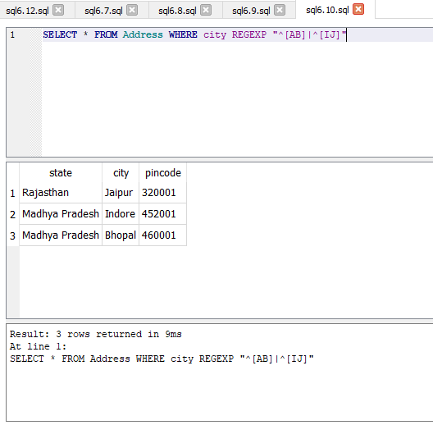

**Exercise 11**

* Query:

SELECT * FROM Agent WHERE first_name REGEXP "\bV"

(In SQLite the Regular Expression [[:<:]] does not work, instead we have to use “\b” which signifies the beginning of the word.)

* View:

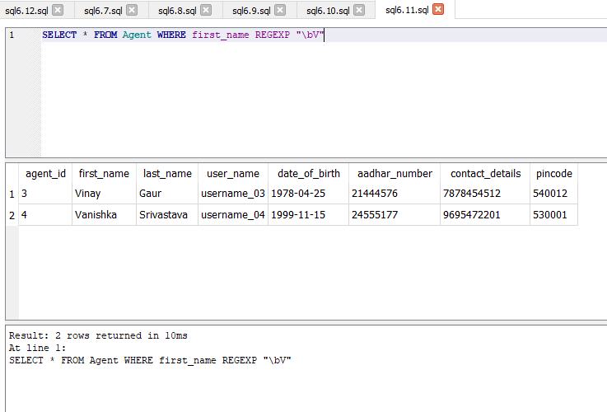

**Exercise 12**

* Query:

SELECT * FROM Customer WHERE last_name REGEXP "[:alpha:]"

* View:

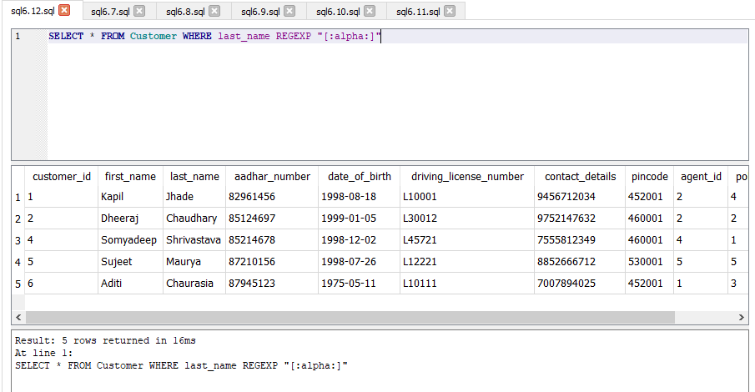

REFERENCE TABLES

**Accident:**

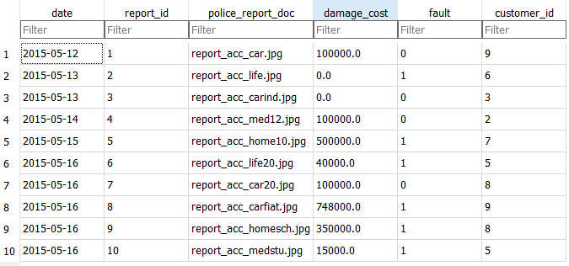

**Address:**

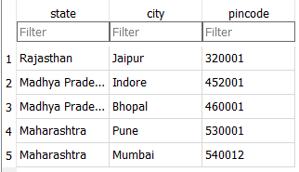

**Agent:**

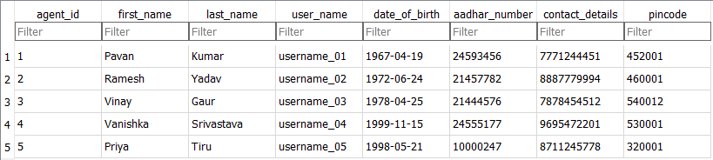

**Customer:**

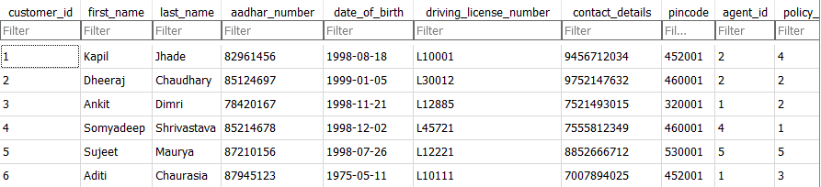

**Insurance:**

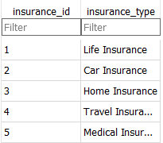

**Payment:**

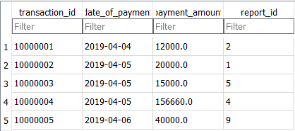

**Policy:**

